# Errors Found:

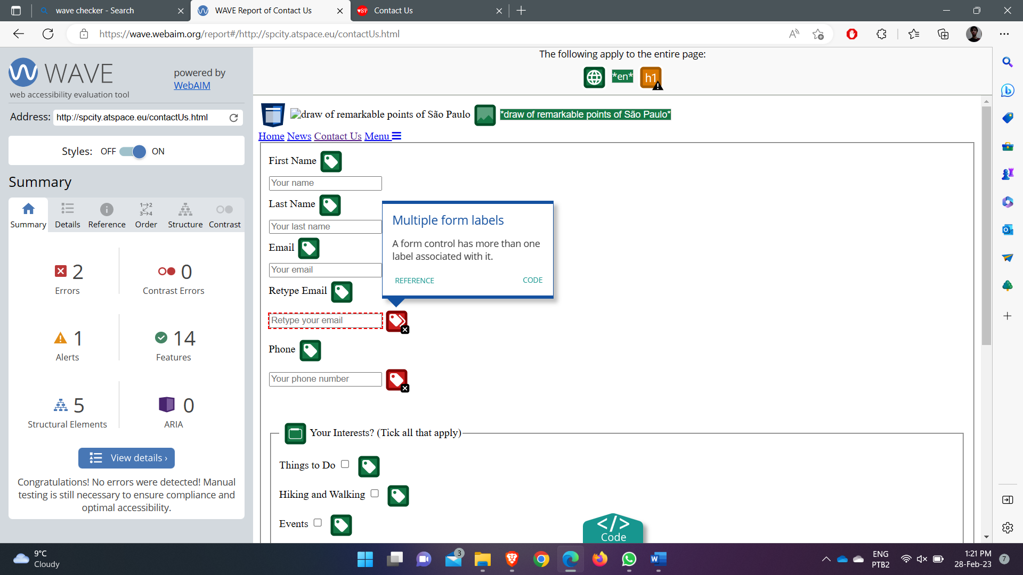

# Errors Fixed:



